***GP Connect PCN***



***November 2024 PCN Newsletter***

## Introduction

## This edition we will speak about:

* The successful Community Event
* Our successful Enhanced Access Clinic
* Extra Appointments through our Winter Hubs
* Our social media channels.
* PCN Social Care Service: Joy
* Health and wellbeing team updates

# ***PCN Community Engagement Event: Thank you to everyone for coming***!

In June, our PCN hosted a fantastic community networking event,

open to all, at the Shree Krishna Temple in Coventry.

It was a wonderful opportunity to connect with our community and learn about the various services available to support your health and well-being.

The event showcased a range of services, including:

***Talking Therapies -*** Accessing mental health support has never been easier. Our team of experts is here to help you manage stress, anxiety, and depression.

***Continence Services -*** Discreet and professional support for bladder and bowel control issues

***PCN Digital Team -*** the convenience of online consultations, appointment booking, and accessing your medical records digitally.

***PCN Paramedics -*** Our paramedics are working hard to improve community health and well-being through a variety of initiatives, including health checks and support for vulnerable individuals.

The PCN Building a Healthier Community Together

The success of our PCN community event highlights the importance of collaboration between healthcare providers and the community.

The PCN works with the community to address health inequalities and create a healthier future for everyone. We look forward to more opportunities to connect with our community.

[Click here to watch our video of the event!](https://www.youtube.com/watch?v=1V1jFdcC2SA)

# ***Enhanced Access (EA): Making Healthcare More Convenient for You!***

**Coventry GP Connect PCN has been working hard to provide Enhanced Access to healthcare services for our patients.**

This means you can book appointments **outside of regular GP Surgery hours**, including evenings and weekends.

Our dedicated team of healthcare professionals, including GPs, Nurses, Advanced Nurse Practitioners and other Clinicians, are available to see you during these **extended hours**.

By offering these **additional appointments**, we aim to make healthcare more accessible and convenient for you.

Below is a table showing number of EA Appointments delivered:

|  |  |  |  |  |  |
| --- | --- | --- | --- | --- | --- |
| Month | GP | Other Clinicians | Total Appts | GP% | Other% |
| May | 361 | 187 | 548 | 66 | 34 |
| June | 369 | 175 | 544 | 68 | 32 |
| July | 335 | 161 | 496 | 68 | 32 |
| August | 390 | 201 | 597 | 66 | 34 |
| September | 360 | 161 | 521 | 69 | 31 |
| October | 333 | 154 | 487 | 68 | 32 |
| **Total** | **2482** | **1205** | **3687** | **67** | **33** |

If you're interested in booking an enhanced access appointment, please contact your GP practice.

# ***Winter Hub (Enhanced Access) A PCN Additional Service***

**Helping with increased demand of appointments this Winter.**

**What is the PCN Winter Hub?**

The Winter Hub offers extended GP practice hours, operating from **Monday to Friday, 5pm to 8:30pm**. This means you can access healthcare services outside of **regular working hours**, making it easier to fit appointments into your busy schedule.

This is an additional service available to **all patients of our PCN** Member Practices, giving access to GPs, nurses, and other clinicians.

**To book an appointment at the Winter Hub** simply contact your GP practice. They will be able to assist you in booking a suitable time.

# ***Stay Warm, Stay Healthy This Winter with the NHS***

**The NHS wants to ensure you stay warm and well.**

**Here are some key takeaways from their "Stay Well This Winter" campaign:**

**Protecting Yourself from the Cold**

Heating Your Home: Aim for a living room temperature of around 18°C (65°F). This helps prevent cold-related illnesses, especially for vulnerable individuals.

**Staying Warm When Outside**

Dress in layers and wear a hat, scarf, and gloves when outdoors. Remember, you lose a lot of heat from your head!

**Looking Out for Others**

Check in on elderly or vulnerable neighbours who might   
struggle to heat their homes.

**Additional Tips**

Eat Well: Maintain a balanced diet that includes plenty of fruits and vegetables to support your immune system.

**Stay Active**

Regular exercise, even light activities indoors, can help improve  
circulation and keep you warm.

**Get Your Vaccinations**

Protect yourself against flu and COVID-19 by getting your vaccinations.   
By following these simple tips, you can stay healthy and   
enjoy a comfortable winter.

For more information, visit the NHS website:

<https://www.nhs.uk/live-well/seasonal-health/keep-warm-keep-well/>

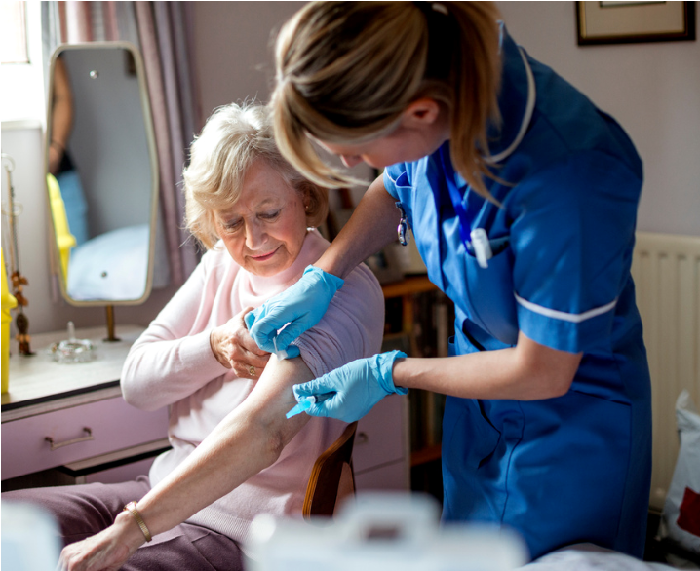**Some people are more vulnerable to the effects of cold weather**

* *people aged 65 and older*
* *babies and children under the age of 5*
* *people on a low income (so cannot afford heating) people who have a long-term health condition*
* *people with a disability pregnant women*
* *people who have a mental health condition*

# ***Join Us on Social Media!***

You can now follow us on Facebook, X (formerly Twitter), YouTube, and our PCN website and mailing list.

**Why Social Media?**

Social media is a powerful tool for connecting with our community and sharing important health information. It's a great way to stay up to date on the latest news and events, ask questions, and get involved in discussions.

**Social Media and the NHS**

The NHS is committed to using social media to improve communication with patients and the public.

**Improve access to healthcare information!**

We can share helpful tips, advice, and resources on a variety of health topics.

**Promote health and wellbeing!**

We can raise awareness of health issues and encourage healthy behaviours.

**Build trust and confidence in the NHS** We can share stories of how the NHS is making a difference in people's lives.

Social media is a great way for the NHS to reach a wide audience.

& provide info in a way that is accessible and engaging

56.2 million people in the UK are using social media!

That's about 82.8% of the total population!

The NHS & your PCN uses social media to share information about health conditions, treatments, and services.

For example, we might share a post about the importance of getting a flu vaccine or a video about how to manage diabetes.

YouTube was founded in February 2005. you can still find the first video, titled  
**"Me at the zoo,"**

**YouTube** is the second most popular website in the world, after Google.

Over 5 billion videos are watched on YouTube every day!

**YouTube** is a great way to learn new things. There are many educational channels on YouTube that teach everything from cooking to yoga & meditation.

The first tweet was sent on March 21, 2006, and read "just setting up my twttr." Twitter quickly gained popularity and became a platform for people to share news, ideas, and connect with others.

Feel free to contact and suggest content or articles:

**Links:**

**Twitter**

[**@GPConnectPCN**](https://x.com/GPConnectPCN)

**Facebook**

[**Facebook Page**](https://www.facebook.com/profile.php?id=61559055276830)

**YouTube**

[**@CoventryGPConnectPCN**](https://www.youtube.com/@CoventryGPConnectPCN)

# ***Joy - A New Way to Support Your Health and Wellbeing***

**Did you know that one in five GP appointments are for non-medical reasons?**

And that 70% of people referred to Adult Social Care could benefit from services that address the root causes of their problems, like **loneliness or debt-related stress?**

That's where Joy comes in, a digital platform that connects people to life-changing local services, so they can get the support they need,   
when they need it.

**How does Joy work?**  
Your GP Surgery or another healthcare professional can refer you via Joy.   
[**For some services on the Joy Market Place of Services**](https://services.thejoyapp.com/), you can contact the service yourself. Once referred, you'll be matched with a link worker who will work with you to understand your needs and connect you with the right support.

**Why use Joy?**

* **Improved Health & Wellbeing** - Joy can help you address the social factors that affect your health, such as loneliness, isolation, and financial difficulties.
* **Enhanced Patient Experience** - streamlined user-friendly experience, making it easy to access support
* **Efficient Referrals** - Joy is integrated with the **clinical system, making it easy for Practices to refer patients.**
* **Better Outcomes** - helps provide **preventative care** and improve long-term health outcomes.

**From 15th December, Joy will become the single channel for   
non-clinical referrals.**

**Joy - A New Way to Support Your Health and Wellbeing**

* With **Joy**, we can Instantly refer clients to high-quality support on our marketplace of services.
* Automatically keep our service directory up to date  
  Measure the effectiveness of our preventive health initiatives.
* Identify health inequalities & gaps in service provision   
  Work with organisations to enable connection with people in Coventry.

**Example Services**

[**Age UK Coventry and Warwickshire**](https://www.ageuk.org.uk/coventryandwarwickshire/our-services/)**,** Provides services for older people, including social activities and advice

[**Talking Therapies Coventry & Warwickshire**](https://services.thejoyapp.com/en/listings/13669-talking-therapies-coventry-and-warwickshire)**,** free NHS service to help people [**Coventry Haven Women's Aid**](https://services.thejoyapp.com/en/listings/14304-coventry-haven-womens-aid)**,** Provides support & advice to women and children experiencing domestic abuse  
[**Coventry Mind,**](https://services.thejoyapp.com/en/listings/20922-supported-self-help) Offers mental wellness support services

[**Creative Kindness**](https://services.thejoyapp.com/en/listings/20250-craft-sessions) run friendly craft sessions to tackle loneliness and isolation, and create safe spaces for people to find friends and build community

**What Does This Mean for You?**

***If you're a patient,*** Joy means you can get the support you need more quickly & easily ***If you're a healthcare professional***, Joy means you can spend more time focusing on patient care, knowing that your patients are getting the support they need **If you're a community member**, Joy means a healthier happier community for everyone.

**From 15th December, Joy will become the single channel   
for non-clinical referrals**

The PCN will be able to use the system to identify where best   
to focus PCN resource.

If you have any questions about **Joy**, please contact   
the PCN or your GP practice.



# ***GP Connect New Health and Wellbeing Team Member and Services***

**Some exciting changes to our Health and Wellbeing Team!**

**New Coach Joining the Team**

Bethany, one of our talented social prescribers, is expanding her role to join the health coaching team. Bethany will be offering 1-2-1 coaching sessions to help patients with a variety of issues, including:

* Understanding and controlling negative thought patterns
* Managing anxiety
* Improving self-confidence and self-esteem
* Managing low mood
* Supporting with perimenopause and menopause

Bethany is passionate about helping people to improve their mental health and well-being. She is looking forward to working with patients to help them achieve their goals.

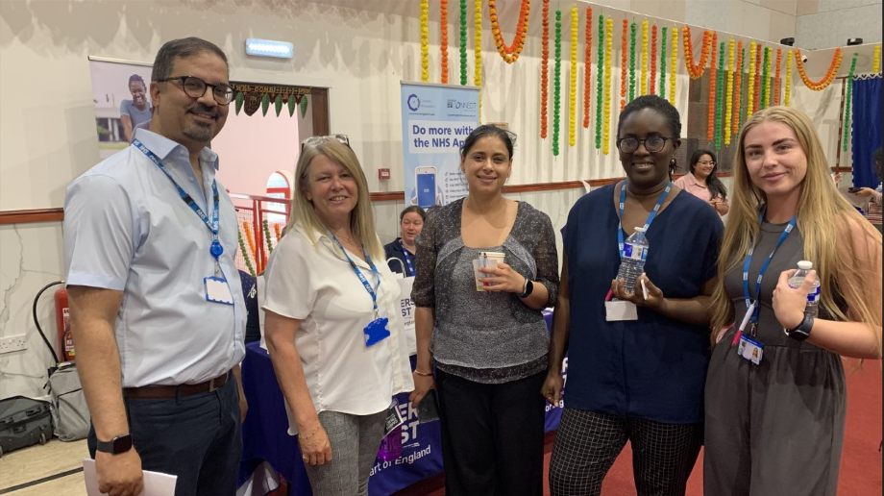

**Mental Health Coaching with Serena**



Serena, our Mental Health Coach, continues to offer 1-2-1 coaching sessions to patients. She can help with a range of issues, including those listed above.

A close-up of hands holding a green ribbon


Serena has also hosted a patient event to mark   
World Mental Health Day.

More details in the next Newsletter! If you're interested in learning more about our health and wellbeing services, please contact your GP practice.