SOCIAL PRESCRIBING SERVICE
In your GP surgery

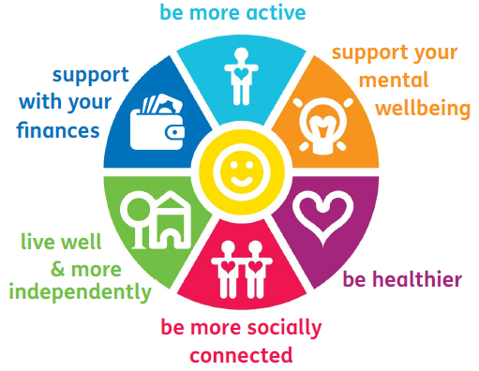

Your doctor isn’t the only person who can help you feel better! Social Prescribing helps you to explore extra services that may support you to improve your health, wellbeing and
independence.

Many things affect a person’s health and wellbeing. You may be feeling stressed by work, have money worries, or housing problems. You may be feeling lonely or isolated or be finding it difficult to manage a long-term health condition.
That’s where Social Prescribing comes in. Your Practice has a dedicated Social Prescribing Link Workers who are there to listen and help you access people and activities that can support you and help you to feel better.

Together you will be able to:

- Explore what is important for your life and wellbeing
- Identify the local activities and services you can benefit from
- Give you support and encouragement to start using services that can help you.
- Improve your health and wellbeing by addressing what matters to you and giving you control over your health.

Social Prescribing can connect you with and help you access many services in your local community including:
- Healthy lifestyles and active living
- Arts, music, outdoor and creative activities
- Befriending, counselling and other support groups
- Helping you meet like-minded people and getting involved in local groups and activities around what’s interesting to you
- Housing issues
- Welfare benefits, and financial support and advice
- Access to employment, training, and volunteering
- Education and learning
- Supporting Carers in their role
- Identifying care needs

If you would like to access the service please speak to your GP reception staff for a referral.
You can speak to your Social Prescriber face to face, by telephone or a home visit can be arranged if you are housebound or struggling with a condition that makes it difficult for you to attend the surgery.
Your Practice’s Social Prescribing Link Workers are:
Jo Chiverton, Bethany Wilde, Cynthia Blay and Donna Barnes.

